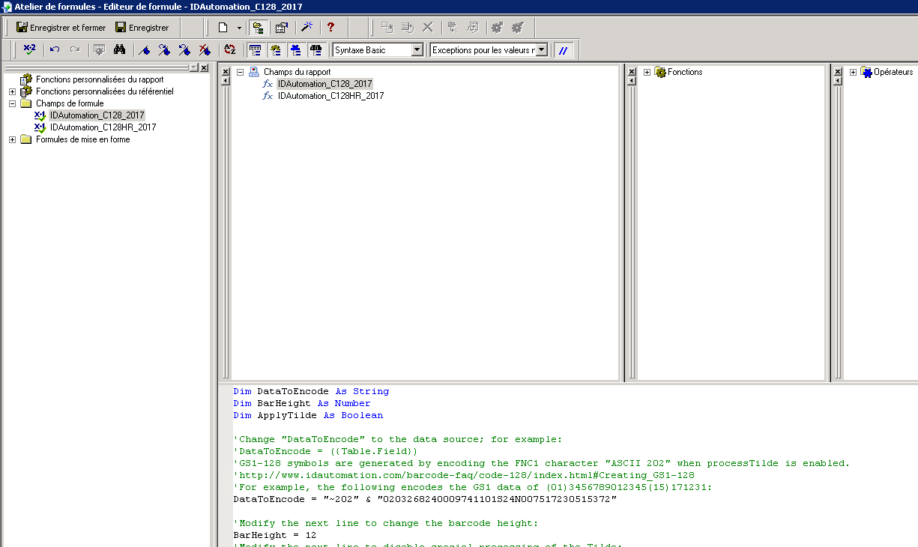

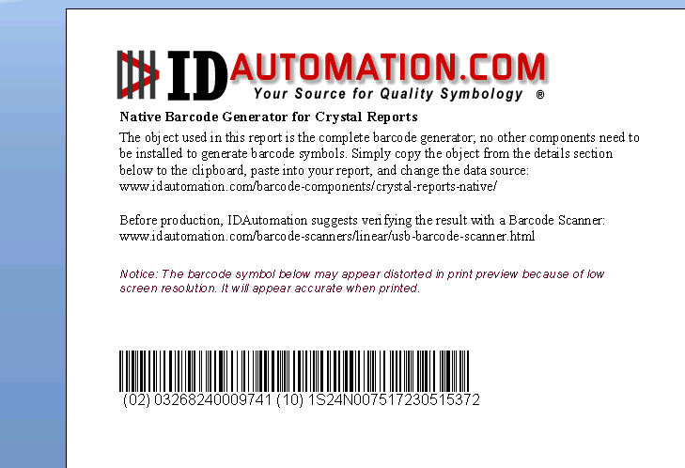
Nous avons besoin de cette codification

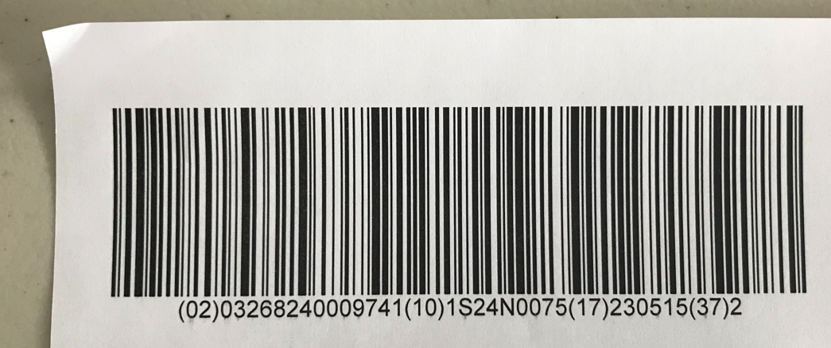

Notre version
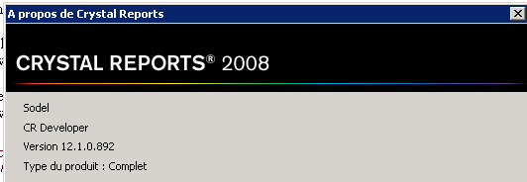

Je n’ai pas les polices GS1 128 (Fonts) dans mon package

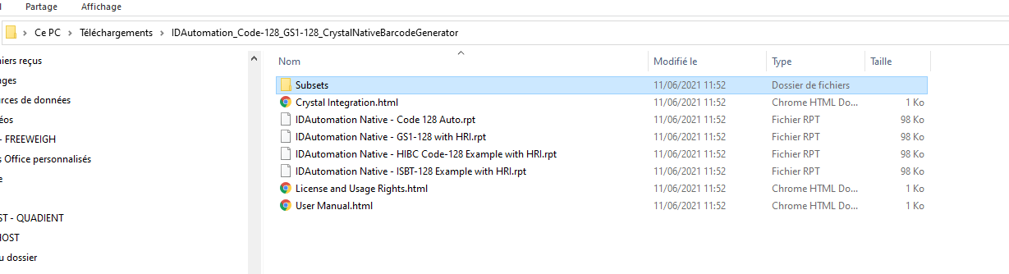
Dans Crystal :
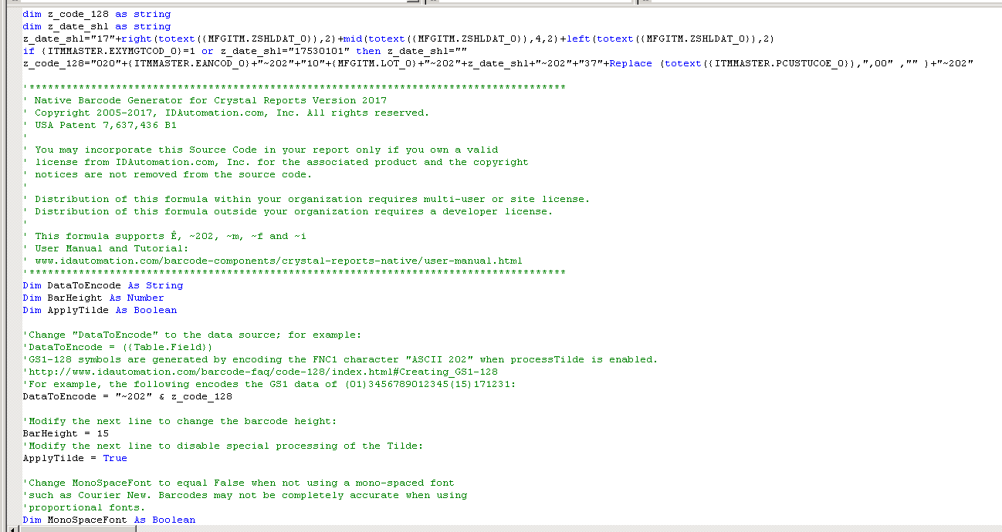

dim z_code_128 as string
dim z_date_shl as string
z_date_shl="17"+right(totext({MFGITM.ZSHLDAT_0}),2)+mid(totext({MFGITM.ZSHLDAT_0}),4,2)+left(totext({MFGITM.ZSHLDAT_0}),2)
if {ITMMASTER.EXYMGTCOD_0}=1 or z_date_shl="17530101" then z_date_shl=""
z_code_128="020"+{ITMMASTER.EANCOD_0}+"~202"+"10"+{MFGITM.LOT_0}+"~202"+z_date_shl+"~202"+"37"+Replace (totext({ITMMASTER.PCUSTUCOE_0}),",00" ,"" )+"~202"

'***************************************************************************************
' Native Barcode Generator for Crystal Reports Version 2017
' Copyright 2005-2017, IDAutomation.com, Inc. All rights reserved.
' USA Patent 7,637,436 B1
'
' You may incorporate this Source Code in your report only if you own a valid
' license from IDAutomation.com, Inc. for the associated product and the copyright
' notices are not removed from the source code.
'
' Distribution of this formula within your organization requires multi-user or site license.
' Distribution of this formula outside your organization requires a developer license.
'
' This formula supports Ê, ~202, ~m, ~f and ~i
' User Manual and Tutorial:
' www.idautomation.com/barcode-components/crystal-reports-native/user-manual.html
'***************************************************************************************
Dim DataToEncode As String
Dim BarHeight As Number
Dim ApplyTilde As Boolean

'Change "DataToEncode" to the data source; for example:
'DataToEncode = ({Table.Field})
'GS1-128 symbols are generated by encoding the FNC1 character "ASCII 202" when processTilde is enabled.
'http://www.idautomation.com/barcode-faq/code-128/index.html#Creating_GS1-128
'For example, the following encodes the GS1 data of (01)3456789012345(15)171231:
DataToEncode = "~202" & z_code_128

'Modify the next line to change the barcode height:
BarHeight = 15
'Modify the next line to disable special processing of the Tilde:
ApplyTilde = True

'Change MonoSpaceFont to equal False when not using a mono-spaced font
'such as Courier New. Barcodes may not be completely accurate when using
'proportional fonts.
Dim MonoSpaceFont As Boolean
MonoSpaceFont = True
Dim DataToPrint as String
Dim WeightedTotal As Number
Dim SymbolString As String
Dim StringLength As Number
StringLength = Len(DataToEncode)
Dim CurrentCharNum As Number
Dim CurrentValue As Number
Dim WeightValue As Number
Dim NumCharsTaken As Number
Dim CheckDigitValue As Number
Dim PrintableString As String
Dim Factor As Number
Dim I As Number
Dim J As Number
Dim CorrectFNC As Number
Dim nwPattern As String
Dim OnlyCorrectData As String
Dim OnlyNumberData As String
Dim OnlyNumberDataRev As String
Dim DataToFormat As String
Dim C128Start As String
PrintableString = ""
Formula = ""
Dim ArrayBase As Number
Dim CurrentChar As String
ArrayBase = 1 'Array Base is 1 in Crystal Reports and 0 in Microsoft VB
Dim CurrentEncoding As String
CurrentEncoding = ""
DataToPrint = ""
CorrectFNC = 0
'in case ApplyTilde is null, set it to false
If ApplyTilde <> True Then ApplyTilde = False
PrintableString = ""
'ApplyTilde ~???
If ApplyTilde Then

Dim OutString As String
Dim CharsAdded As Number
Dim StringToCheck As String
Dim M10StringLength As Number
Dim M10OnlyCorrectData As String
Dim M10Factor As Number
Dim M10WeightedTotal As Number
Dim M10CheckDigit As Number

Dim strTemp as String
Dim datamod as String
Dim F43Set as String
Dim F43WeightTotal as Number
Dim M37Correct as String
Dim M37CharCode As Number
Dim M37CharValue As Number
Dim M37WeightTotal As Number
Dim M37CheckDigit As Number

F43Set = "0123456789ABCDEFGHIJKLMNOPQRSTUVWXYZ-. $/+%"

OnlyCorrectData = ""
StringLength = Len(DataToEncode)
For I = 1 To StringLength
If (I < StringLength - 2) And Mid(DataToEncode, I, 1) = "~" And IsNumeric(Mid(DataToEncode, I + 1, 3)) Then
CurrentCharNum = Val(Mid(DataToEncode, I + 1, 3))
OnlyCorrectData = OnlyCorrectData & ChrW(CurrentCharNum)
I = I + 3
Else
OnlyCorrectData = OnlyCorrectData & Mid(DataToEncode, I, 1)
End If
Next I
DataToEncode = OnlyCorrectData
End If
'ApplyTilde ~m??
If ApplyTilde Then
OutString = ""
StringLength = Len(DataToEncode)
For I = 1 To StringLength
'' LM 2017
'' check tilde string for ~mNN (MOD10 for GS1) or ~fNN (MOD43 for HIBC) or ~iNN (MOD37 for ISBT)
If (i < StringLength - 2) And _
(Mid(DataToEncode, i, 2) = "~m" Or Mid(DataToEncode, i, 2) = "~f" Or Mid(DataToEncode, i, 2) = "~i") And _
IsNumeric(Mid(DataToEncode, i + 2, 2)) Then

WeightValue = Val(Mid(DataToEncode, i + 2, 2))

If Mid(DataToEncode, i, 2) = "~m" Then

'' ~mNN (MOD10 for GS1)
datamod = ""
CharsAdded = 0

For j = i-1 To 1 Step -1
If IsNumeric(Mid(OutString, j, 1)) Then
datamod = Mid(OutString, j, 1) & datamod
CharsAdded = CharsAdded + 1
End If
'when the number of digits added to StringToCheck equals the weight value exit the for loop
If CharsAdded = WeightValue Then
Exit For
End If
Next j

'' MODU10
M10OnlyCorrectData = ""
M10StringLength = Len(datamod)
'Check to make sure data is numeric and remove dashes, etc.
For j = 1 To M10StringLength
'Add all numbers to OnlyCorrectData string
if IsNumeric(Mid(datamod, j, 1)) Then M10OnlyCorrectData = M10OnlyCorrectData & Mid(datamod, j, 1)
Next j

'Generate MOD 10 check digit
M10Factor = 3
M10WeightedTotal = 0
M10StringLength = Len(M10OnlyCorrectData)
For j = M10StringLength To 1 Step -1
'Get the value of each number starting at the end
'CurrentCharNum = Mid(M10NumberData, I, 1)
'Multiply by the weighting factor which is 3,1,3,1...
'and add the sum together
M10WeightedTotal = M10WeightedTotal + (Val(Mid(M10OnlyCorrectData, j, 1)) * M10Factor)
'Change factor for next calculation
M10Factor = 4 - M10Factor
Next j
'Find the CheckDigit by finding the smallest number that = a multiple of 10
j = (M10WeightedTotal Mod 10)
If j <> 0 Then
CheckDigitValue = (10 - j)
Else
CheckDigitValue = 0
End If
OutString = OutString & ChrW(CheckDigitValue + 48)

elseif Mid(DataToEncode, i, 2) = "~f" Then

'' ~fNN (MOD43 for HIBC)
F43WeightTotal = 0
datamod = ""
CharsAdded = 0

For j = i-1 To 1 Step -1
If InStr(F43Set, Mid(OutString, j, 1)) > 0 Then
datamod = Mid(OutString, j, 1) & datamod
CharsAdded = CharsAdded + 1
End If
'when the number of digits added to StringToCheck equals the weight value exit the for loop
If CharsAdded = WeightValue Then
Exit For
End If
Next j
M10StringLength = Len(datamod)
For j = 1 To M10StringLength
F43WeightTotal = F43WeightTotal + (InStr(F43Set, Mid(datamod, j, 1)) - 1)
Next j
F43WeightTotal = (F43WeightTotal Mod 43)
OutString = OutString & Mid(F43Set, F43WeightTotal + 1, 1)

elseif (Mid(DataToEncode, i, 2) = "~i") Then

'' ~iNN (MOD37 for ISBT)
M37Correct = ""
M37CharCode = 0
M37CharValue = 0
M37WeightTotal = 0
M37CheckDigit = 0

datamod = ""
CharsAdded = 0

For j = i-1 To 1 Step -1
M37CharCode = Asc(Mid(OutString, j, 1))
If (M37CharCode > 47 And M37CharCode < 58) Or (M37CharCode > 64 And M37CharCode < 91) Then
datamod = Mid(OutString, j, 1) & datamod
CharsAdded = CharsAdded + 1
End If
'when the number of digits added to StringToCheck equals the weight value exit the for loop
If CharsAdded = WeightValue Then
Exit For
End If
Next j

M10StringLength = Len(datamod)
For j = 1 To M10StringLength
M37CharCode = Asc(Mid(datamod, j, 1))
'' 0-9
If (M37CharCode > 47 And M37CharCode < 58) Then M37CharValue = M37CharCode - 48
'' A-Z
If (M37CharCode > 64 And M37CharCode < 591) Then M37CharValue = M37CharCode - 55

M37WeightTotal = ((M37WeightTotal + M37CharValue) * 2) Mod 37
Next j

M37CheckDigit = (38 - M37WeightTotal) Mod 37
strTemp = ""
if (M37CheckDigit < 10) then strTemp = Chr(M37CheckDigit + 48) '' 0-9
if (M37CheckDigit < 36 And M37CheckDigit > 9) Then strTemp = Chr(M37CheckDigit + 55) '' A-Z
if (M37CheckDigit = 36) Then strTemp = Chr(42)

OutString = OutString & strTemp

end if

i = i + 3
Else
OutString = OutString & Mid(DataToEncode, I, 1)
End If
Next I
DataToEncode = OutString
End If

DataToFormat = DataToEncode
OnlyCorrectData = ""
DataToEncode = ""
DataToPrint = ""
Dim SetC128(128) As String
SetC128 = Array( _
"EFF", "FEF", "FFE", "BBG", "BCF", "CBF", "BFC", "BGB", "CFB", "FBC", _
"FCB", "GBB", "AFJ", "BEJ", "BFI", "AJF", "BIF", "BJE", "FJA", "FAJ", _
"FBI", "EJB", "FIB", "IEI", "IBF", "JAF", "JBE", "IFB", "JEB", "JFA", _
"EEG", "EGE", "GEE", "ACG", "CAG", "CCE", "AGC", "CEC", "CGA", "ECC", _
"GAC", "GCA", "AEK", "AGI", "CEI", "AIG", "AKE", "CIE", "IIE", "ECI", _
"GAI", "EIC", "EKA", "EII", "IAG", "ICE", "KAE", "IEC", "IGA", "KEA", _
"IMA", "FDA", "OAA", "ABH", "ADF", "BAH", "BDE", "DAF", "DBE", "AFD", _
"AHB", "BED", "BHA", "DEB", "DFA", "HBA", "FAD", "MIA", "HAB", "CMA", _
"ABN", "BAN", "BBM", "ANB", "BMB", "BNA", "MBB", "NAB", "NBA", "EEM", _
"EME", "MEE", "AAO", "ACM", "CAM", "AMC", "AOA", "MAC", "MCA", "AIM", _
"AMI", "IAM", "MAI", "EDB", "EBD", "EBJ")
'Here we select character set A, B or C for the START character
'Start A = "EDB"
'Start B = "EBD"
'Start C = "EBJ"
StringLength = Len(DataToFormat)
CurrentCharNum = AscW(Mid(DataToFormat, 1, 1))
'Set A?
If CurrentCharNum < 32 Then C128Start = "EDB"
'Set B?
If CurrentCharNum > 31 And CurrentCharNum < 127 Then C128Start = "EBD"
If CurrentCharNum = 197 Then C128Start = "EBD"

'Updated V5.08 by BDA
'Set C?
If ((StringLength > 3) And IsNumeric(Mid(DataToFormat, 1, 4))) Then C128Start = "EBJ"

'202 & 212-215 is for the FNC1, with this Start C is mandatory
If CurrentCharNum = 202 Then C128Start = "EBJ"
If CurrentCharNum > 211 Then C128Start = "EBJ"
If C128Start = "EDB" Then CurrentEncoding = "A"
If C128Start = "EBD" Then CurrentEncoding = "B"
If C128Start = "EBJ" Then CurrentEncoding = "C"
For I = 1 To StringLength
CurrentCharNum = AscW(Mid(DataToFormat, I, 1))
'check for FNC1 in any set which is ASCII 202 and ASCII 212-219
If ((CurrentCharNum > 201) And (CurrentCharNum < 219)) Then
DataToEncode = DataToEncode & ChrW(202)
'check for switching to character set C
ElseIf CurrentCharNum = 197 Then
If CurrentEncoding = "C" Then 'switch to B
DataToEncode = DataToEncode & ChrW(200)
CurrentEncoding = "B"
End If
DataToEncode = DataToEncode & ChrW(197)
ElseIf ((I < StringLength - 2) And (IsNumeric(Mid(DataToFormat, I, 1))) And (IsNumeric(Mid(DataToFormat, I + 1, 1))) And (IsNumeric(Mid(DataToFormat, I, 4)))) Or ((I < StringLength) And (IsNumeric(Mid(DataToFormat, I, 1))) And (IsNumeric(Mid(DataToFormat, I + 1, 1))) And (CurrentEncoding = "C")) Then
'check to see if we have an odd number of numbers to encode,
'if so, stay in current set and then switch to save space
If CurrentEncoding <> "C" Then
J = I
Factor = 3
Do While J <= StringLength And IsNumeric(Mid(DataToFormat, J, 1))
Factor = 4 - Factor
J = J + 1
Loop
If Factor = 1 Then
'if so stay in current set for 1 character to save space
DataToEncode = DataToEncode & ChrW(CurrentCharNum)
I = I + 1
End If
End If
'switch to set C if not already in it
If CurrentEncoding <> "C" Then DataToEncode = DataToEncode & ChrW(199)
CurrentEncoding = "C"
CurrentChar = Mid(DataToFormat, I, 2)
CurrentValue = Val(CurrentChar)
'set the CurrentValue to the number of String CurrentChar
DataToEncode = DataToEncode & ChrW(CurrentValue + 32)
I = I + 1
'check for switching to character set A
ElseIf (I <= StringLength) And ((AscW(Mid(DataToFormat, I, 1)) < 31) Or ((CurrentEncoding = "A") And (AscW(Mid(DataToFormat, I, 1)) > 32 And (AscW(Mid(DataToFormat, I, 1))) < 96))) Then
'switch to set A if not already in it
If CurrentEncoding <> "A" Then DataToEncode = DataToEncode & ChrW(201)
CurrentEncoding = "A"
'Get the ASCII value of the next character
CurrentCharNum = AscW(Mid(DataToFormat, I, 1))
If CurrentCharNum < 32 Then
DataToEncode = DataToEncode & ChrW(CurrentCharNum + 96)
ElseIf CurrentCharNum > 32 Then
DataToEncode = DataToEncode & ChrW(CurrentCharNum)
End If
'check for switching to character set B
ElseIf (I <= StringLength) And (((AscW(Mid(DataToFormat, I, 1))) > 31) And ((AscW(Mid(DataToFormat, I, 1)))) < 127) Then
'switch to set B if not already in it
If CurrentEncoding <> "B" Then DataToEncode = DataToEncode & ChrW(200)
CurrentEncoding = "B"
'Get the ASCII value of the next character
CurrentCharNum = AscW(Mid(DataToFormat, I, 1))
DataToEncode = DataToEncode & ChrW(CurrentCharNum)
End If
Next I

'<<< Calculate Modulo 103 Check Digit >>>
If C128Start = "EDB" Then WeightedTotal = 103 'CurrentEncoding = "A"
If C128Start = "EBD" Then WeightedTotal = 104 'CurrentEncoding = "B"
If C128Start = "EBJ" Then WeightedTotal = 105 'CurrentEncoding = "C"
StringLength = Len(DataToEncode)
For I = 1 To StringLength
CurrentCharNum = AscW(Mid(DataToEncode, I, 1))
If CurrentCharNum < 135 Then CurrentValue = CurrentCharNum - 32
If CurrentCharNum > 134 Then CurrentValue = CurrentCharNum - 100
If CurrentCharNum = 194 Then CurrentValue = 0
PrintableString = PrintableString & SetC128(CurrentValue + ArrayBase)
CurrentValue = CurrentValue * I
WeightedTotal = WeightedTotal + CurrentValue
Next I
CheckDigitValue = (WeightedTotal Mod 103)
DataToEncode = ""
'GIAH produces the stop character.
DataToPrint = C128Start & PrintableString & SetC128(CheckDigitValue + ArrayBase) & "GIAH"
'Universal to SymbolString conversion
'At this point in the code, DataToPrint is the entire barcode string for the Universal Font
SymbolString = ""
StringLength = Len(DataToPrint)
For I = 1 To StringLength
'Get the value of each
CurrentCharNum = AscW(Mid(DataToPrint, I, 1))
If CurrentCharNum >= 65 And CurrentCharNum <= 68 Then SymbolString = SymbolString & Cstr((11+(CurrentCharNum - 65)),0,"")
If CurrentCharNum >= 69 And CurrentCharNum <= 72 Then SymbolString = SymbolString & Cstr((21+(CurrentCharNum - 69)),0,"")
If CurrentCharNum >= 73 And CurrentCharNum <= 76 Then SymbolString = SymbolString & Cstr((31+(CurrentCharNum - 73)),0,"")
If CurrentCharNum >= 77 And CurrentCharNum <= 80 Then SymbolString = SymbolString & Cstr((41+(CurrentCharNum - 77)),0,"")
If CurrentCharNum >= 87 And CurrentCharNum <= 88 Then SymbolString = SymbolString & Cstr((11+(CurrentCharNum - 87)),0,"")
If CurrentCharNum >= 89 And CurrentCharNum <= 90 Then SymbolString = SymbolString & Cstr((21+(CurrentCharNum - 89)),0,"")
Next I
'SymbolString to Native Conversion
'At this point in the code, SymbolString is the entire barcode string in number form
'For example: 211214142112214121221114311321211232
'Convert SymbolString to PrintableString
Dim ww As String
Dim wb As String
Dim bw As String
Dim bb As String
ww = ChrW(32) 'SPACE
If MonoSpaceFont = False Then ww = ChrW(32) & ChrW(32) & ChrW(32)
wb = ChrW(9616)
bw = ChrW(9612)
bb = ChrW(9608)
CurrentValue = 0
PrintableString = ""
Dim NextDigitUsed As Number
Dim StartOver As Number
NextDigitUsed = 0
Factor = 3
Dim SymbolStringLength
SymbolStringLength = Len(SymbolString) - 1
For I = 1 To SymbolStringLength
CurrentValue = Val(Mid(SymbolString, I, 1))
If NextDigitUsed = 1 Then
'Because the next digit is used, remove 1 from CurrentValue
'unless CurrentValue is already 1
If CurrentValue > 1 then
CurrentValue = CurrentValue - 1
NextDigitUsed = 0
Else
'CurrentValue was used in a previous step
NextDigitUsed = 1
End If
End If
If NextDigitUsed = 1 And CurrentValue = 1 Then
'There is nothing more here to do because the CurrentValue
'was used in a previous step
NextDigitUsed = 0
Else
For J = 1 to CurrentValue
If J = CurrentValue Then
NextDigitUsed = 1
'We are at the end of the bar segment, borrow 1 segment from the next
If Factor = 3 Then PrintableString = PrintableString & bw
If Factor = 1 Then PrintableString = PrintableString & wb
Else
NextDigitUsed = 0
If Factor = 3 Then PrintableString = PrintableString & bb
If Factor = 1 Then PrintableString = PrintableString & ww
J = J+1
End If
Next J
End If
Factor = 4 - Factor
Next I
For I = 1 to BarHeight
Formula = Formula & ChrW(10) & ChrW(13) & PrintableString
Next I

