Rendering from within Crystal Reports Designer environment:
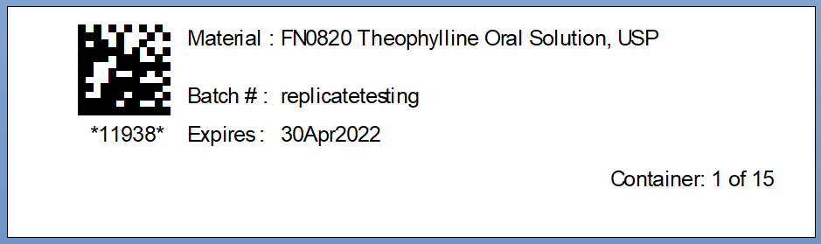
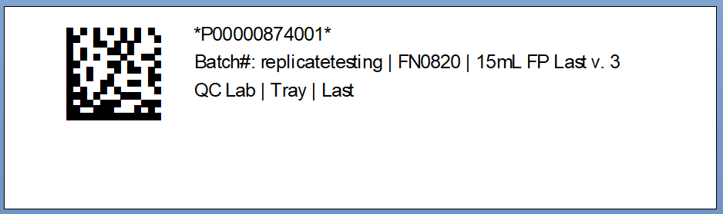

Rendering from with STARLiMS application environment (Crystal Reports “viewer”):
