From: Brent Taylor
Sent: Monday, April 10, 2023 2:43 PM
To: admin@idautomation.com
Cc: gabriella@tbtexas.com
Subject: Need assistance with Code 39 fonts purchased today

Good Afternoon,

I previously purchased a complete font pack that included the “3 0f 9” font listed in the 2nd picture. We noticed we accessed the database from another PC that this particular font was not included with the other IDAutomation fonts installed.

We paid for new download today but upon installation we were unable to find the same font in the new install that is needed in picture 2 and 3.

A lot of time was invested into trying to resolve this before we finally paid to rebuy the fonts and now it is still not working.

Please assist ASAP.

Thank you.

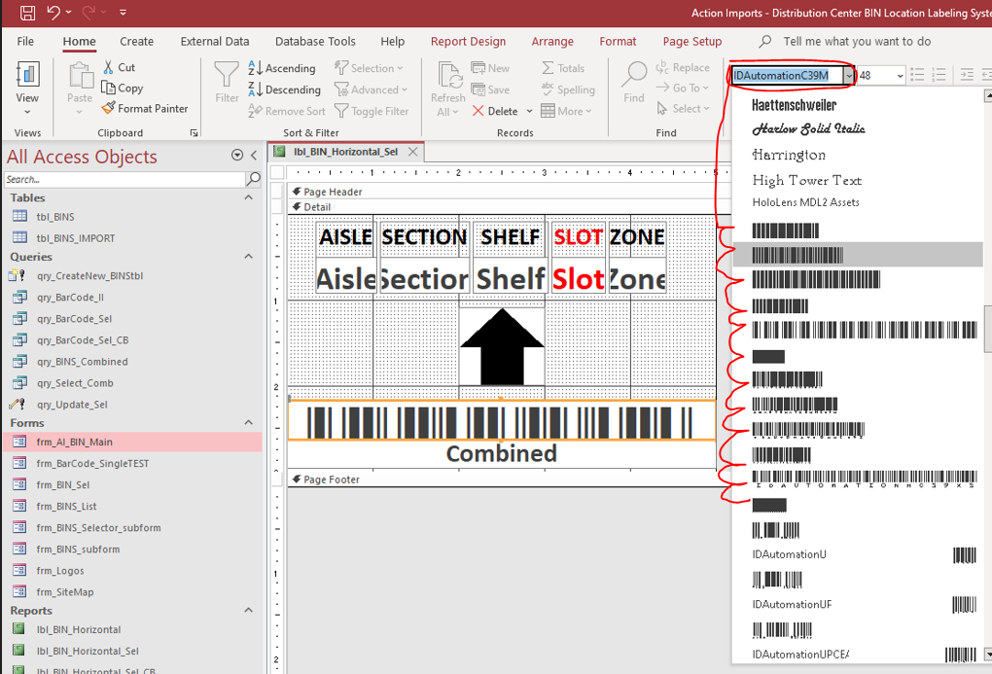

It should look like this:

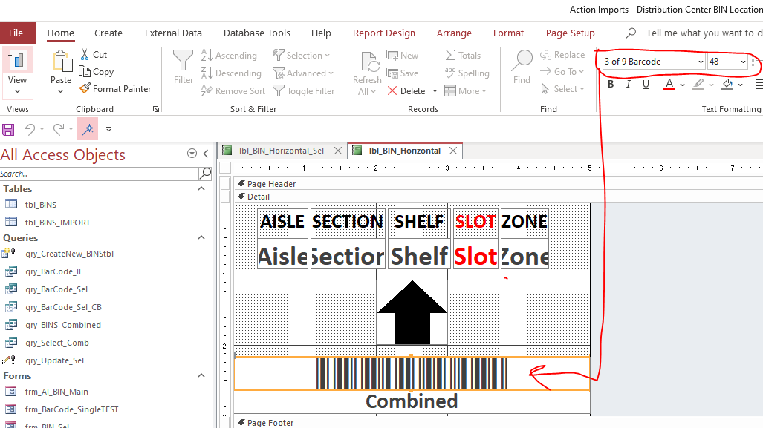

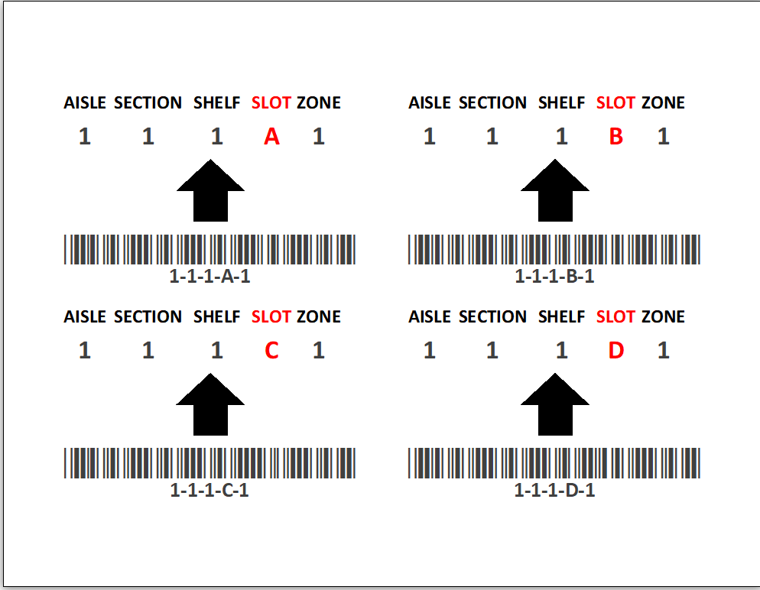

Brent Taylor
Chief Operating Officer
Action Imports
1100 Avenue S
Grand Prairie, Texas 75050
972-623-2222 Office Ext. 102
866-703-3222 Office Ext. 102
972-623-2231 Fax
brent@actionimports.net
https://www.linkedin.com/in/brent-taylor-530566a

The information contained in this e-mail and any documents attached hereto are confidential and may contain copyrighted or trademarked material that is proprietary information and the property of Action Imports. This e-mail message is covered by the Electronic Communications Privacy Act, 18 U.S.C. 2510-2521 and is legally privileged. Unauthorized review, use, disclosure or distribution is strictly prohibited. If you are not the intended recipient, please contact the sender at 972-623-2222, or reply by e-mail, and destroy all copies of the original message.

